Device enrollment admin tasks:
- Be sure your devices are supported.
- Be sure the Apple MDM push certificate is added to Intune, and is active. This certificate is required to enroll macOS devices
After link with ABM and Intune
Configuration Profiles → Devices > macOS > Configuration profiles
Compliance Policies → Devices > macOS > Compliance policies
Security Policies → Endpoint security > Security baselines

1. Set Up Apple Business Manager (ABM)
Before enrolling devices in Intune, you must configure Apple Business Manager (ABM) to integrate with Intune.

Step 1: Create an Apple Business Manager Account
- Go to Apple Business Manager and sign in.
- If you don’t have an account, enroll using your organization’s details.
- Verify your organisation’s domain and link it with ABM.

Step 2: Generate an Apple MDM Push Certificate
- Log in to Microsoft Intune Admin Center: endpoint.microsoft.com
- Navigate to Devices → macOS → Enrollment → Apple MDM Push Certificate
- Download the Intune Certificate Signing Request (CSR)
- Go to Apple Push Certificates Portal
- Upload the CSR file, generate the certificate, and download the MDM push certificate (.pem)
- Upload this file back to Intune.

2. Link Apple Business Manager (ABM) with Intune

Step 1: Create an MDM Server in ABM
- In ABM, go to Settings → Device Management Settings → Add MDM Server
- Name it (e.g., "Intune MDM")
- Upload the Intune public key (.pem) from Intune
- Download the ABM server token (.p7m)

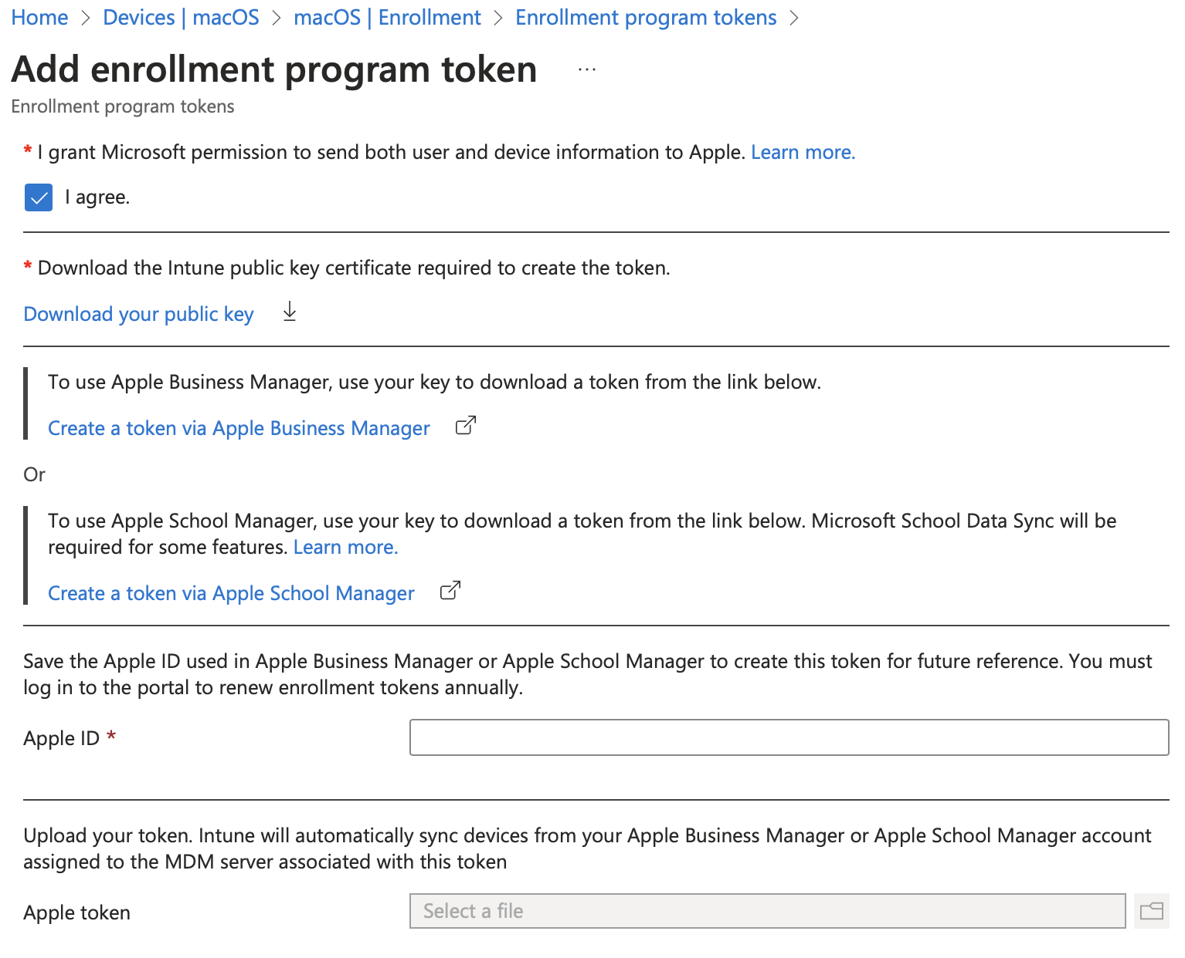

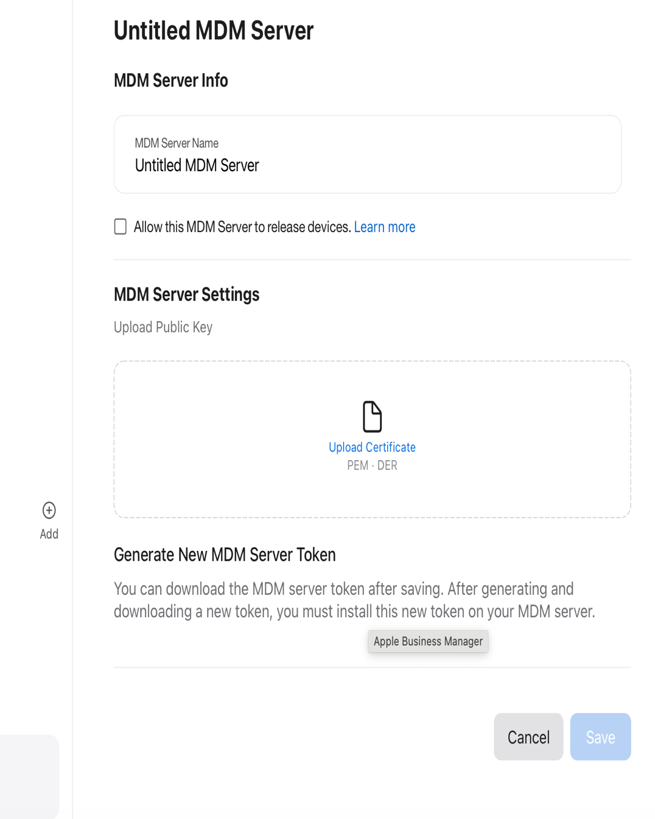

Download the ABM token (.p7m )

Step 2: Import the ABM Token into Intune
- In Intune → Devices → macOS → Enrollment → Apple Enrollment
- Click Automated Device Enrollment (ADE)
- Upload the ABM token (.p7m)
Now, newly purchased macOS devices will be automatically assigned to Intune during setup.

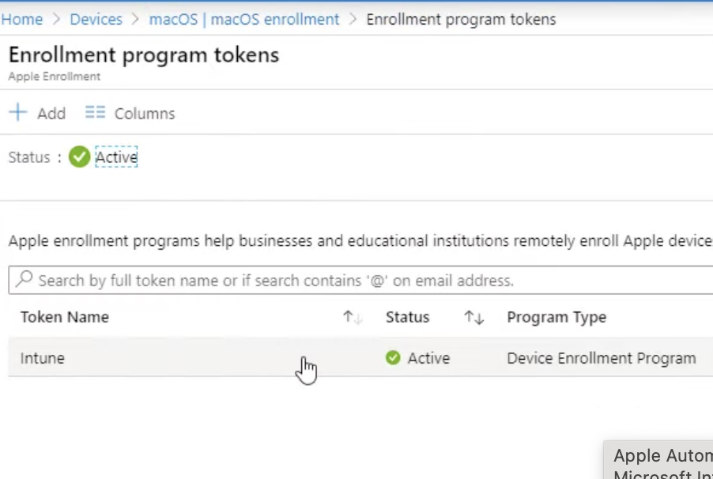

3. Configure macOS Enrollment in Intune
Once ABM and Intune are linked, configure the enrollment settings.

Step 1: Configure Automated Device Enrollment (ADE)
- In Intune → Devices → macOS → Enrollment → Apple Enrollment
- Select Automated Device Enrollment
- Create an enrollment profile:
  - Skip setup screens (like Siri, Apple ID, etc.)
  - Requires Company Portal installation for authentication
  - Assign a user or enroll as Device Enrollment Manager (for shared devices)

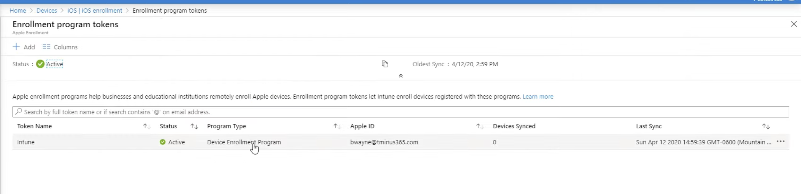
Click on enrollment token, which is we created
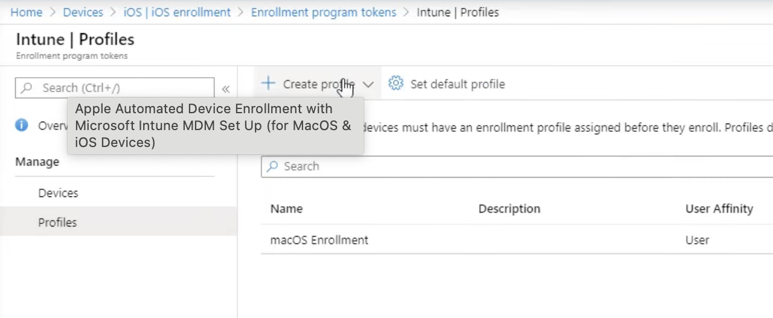

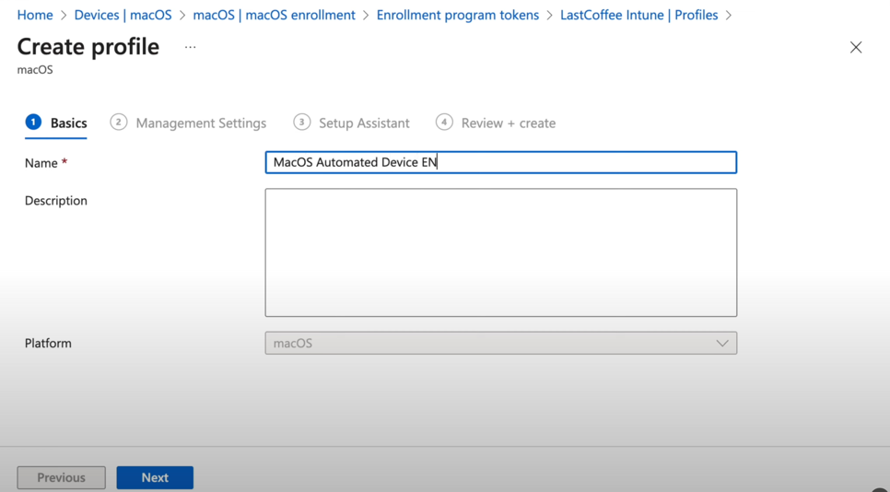
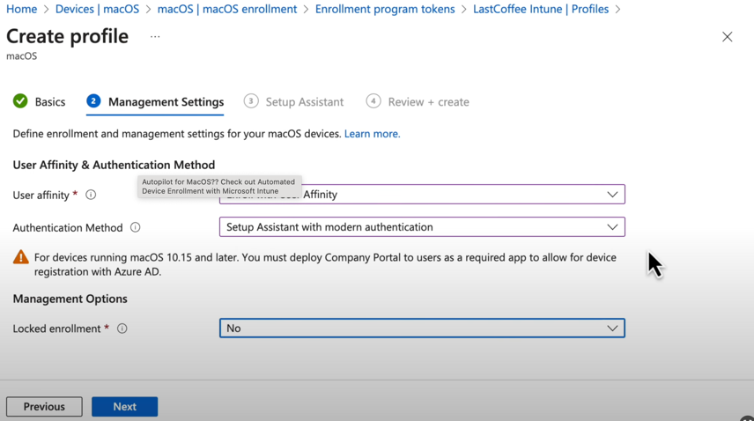
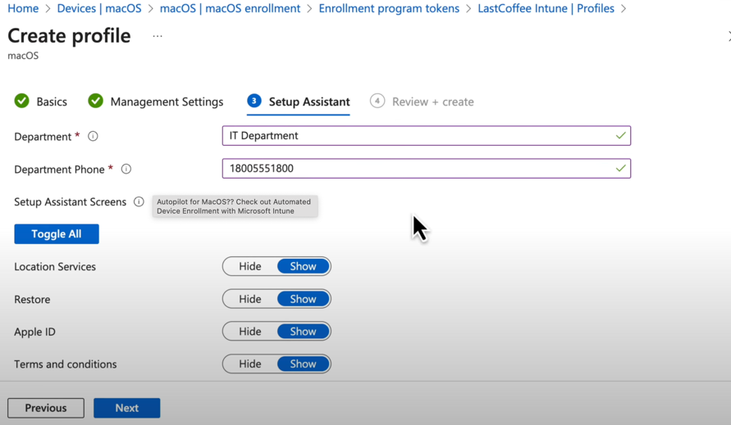
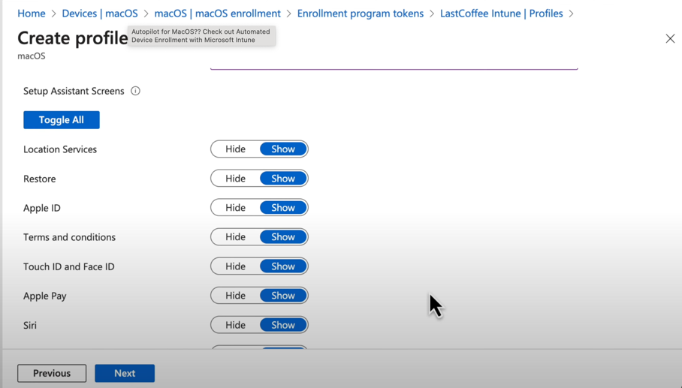
Review and Create! Below image for iOS device.

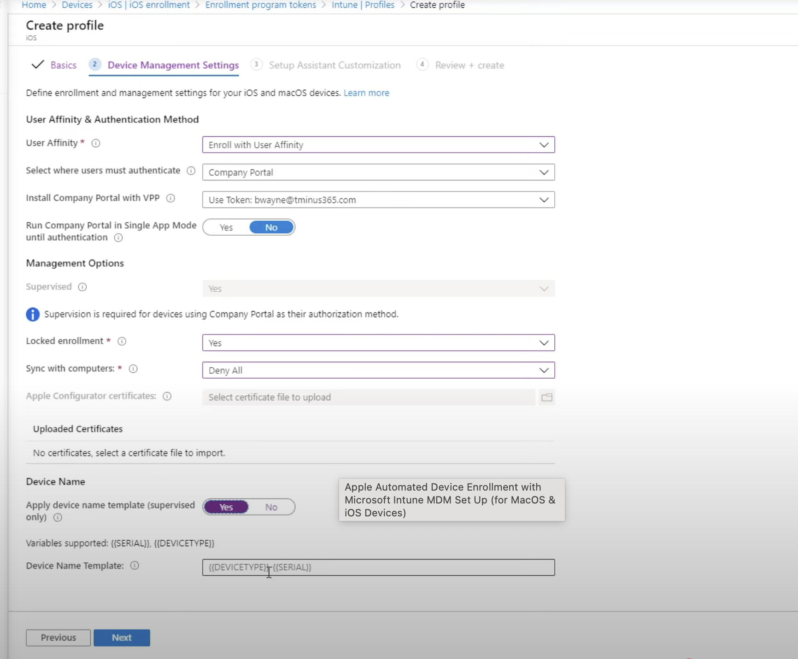
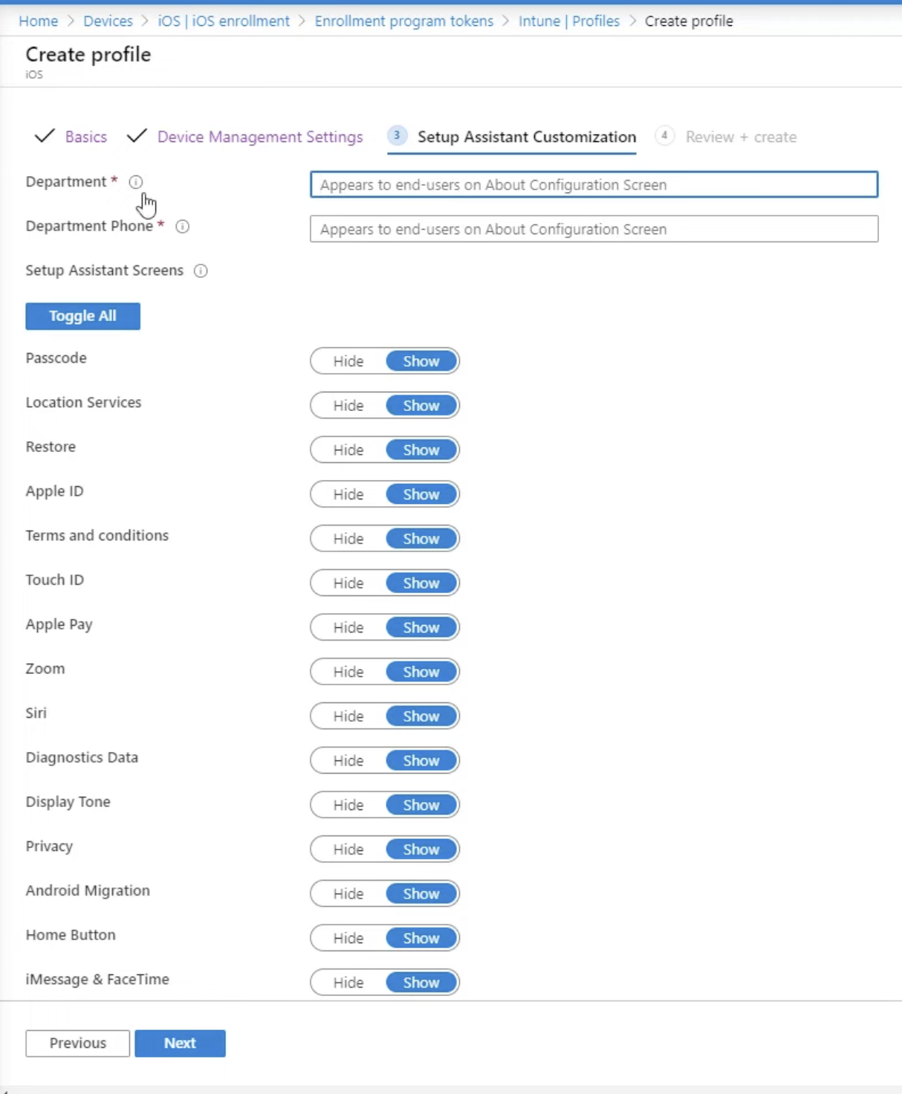
Review and Create!

Step 2: Assign Enrollment Profile to Devices
- In ABM, go to Device Assignments
- Assign newly purchased Macs to the Intune MDM server
- Sync devices in Intune → Apple Enrollment → Enrollment Program Tokens → Sync
Now, when users turn on a Mac, it will automatically enroll in Intune.

4. Configure macOS Policies & Profiles
Once the device is enrolled, deploy configuration profiles.

Step 1: Create Configuration Profiles
- In Intune → Devices → macOS → Configuration Profiles → + Create Profile
- Choose Profile Type:
  - Wi-Fi (corporate SSID, certificate-based authentication)
  - VPN (IPSec, L2TP, IKEv2)
  - Device Restrictions (disable USB, block AirDrop, etc.)
  - FileVault Encryption (enable disk encryption)
  - Login Window Settings (custom banners, auto-login options)

Step 2: Assign Profiles to Users or Devices
- Assign to User Groups (if policies depend on the user)
- Assign to Device Groups (for shared devices)

5. Deploy Applications to macOS
Apps can be deployed via VPP (Volume Purchase Program) or PKG installers.

Step 1: Link ABM to Intune for App Deployment
- In Intune → Tenant Administration → Connectors and Tokens → Apple VPP Tokens
- Download the VPP Token from ABM and upload it to Intune.
https://www.youtube.com/watch?v=0YHdUYalI_c --- Link for content token

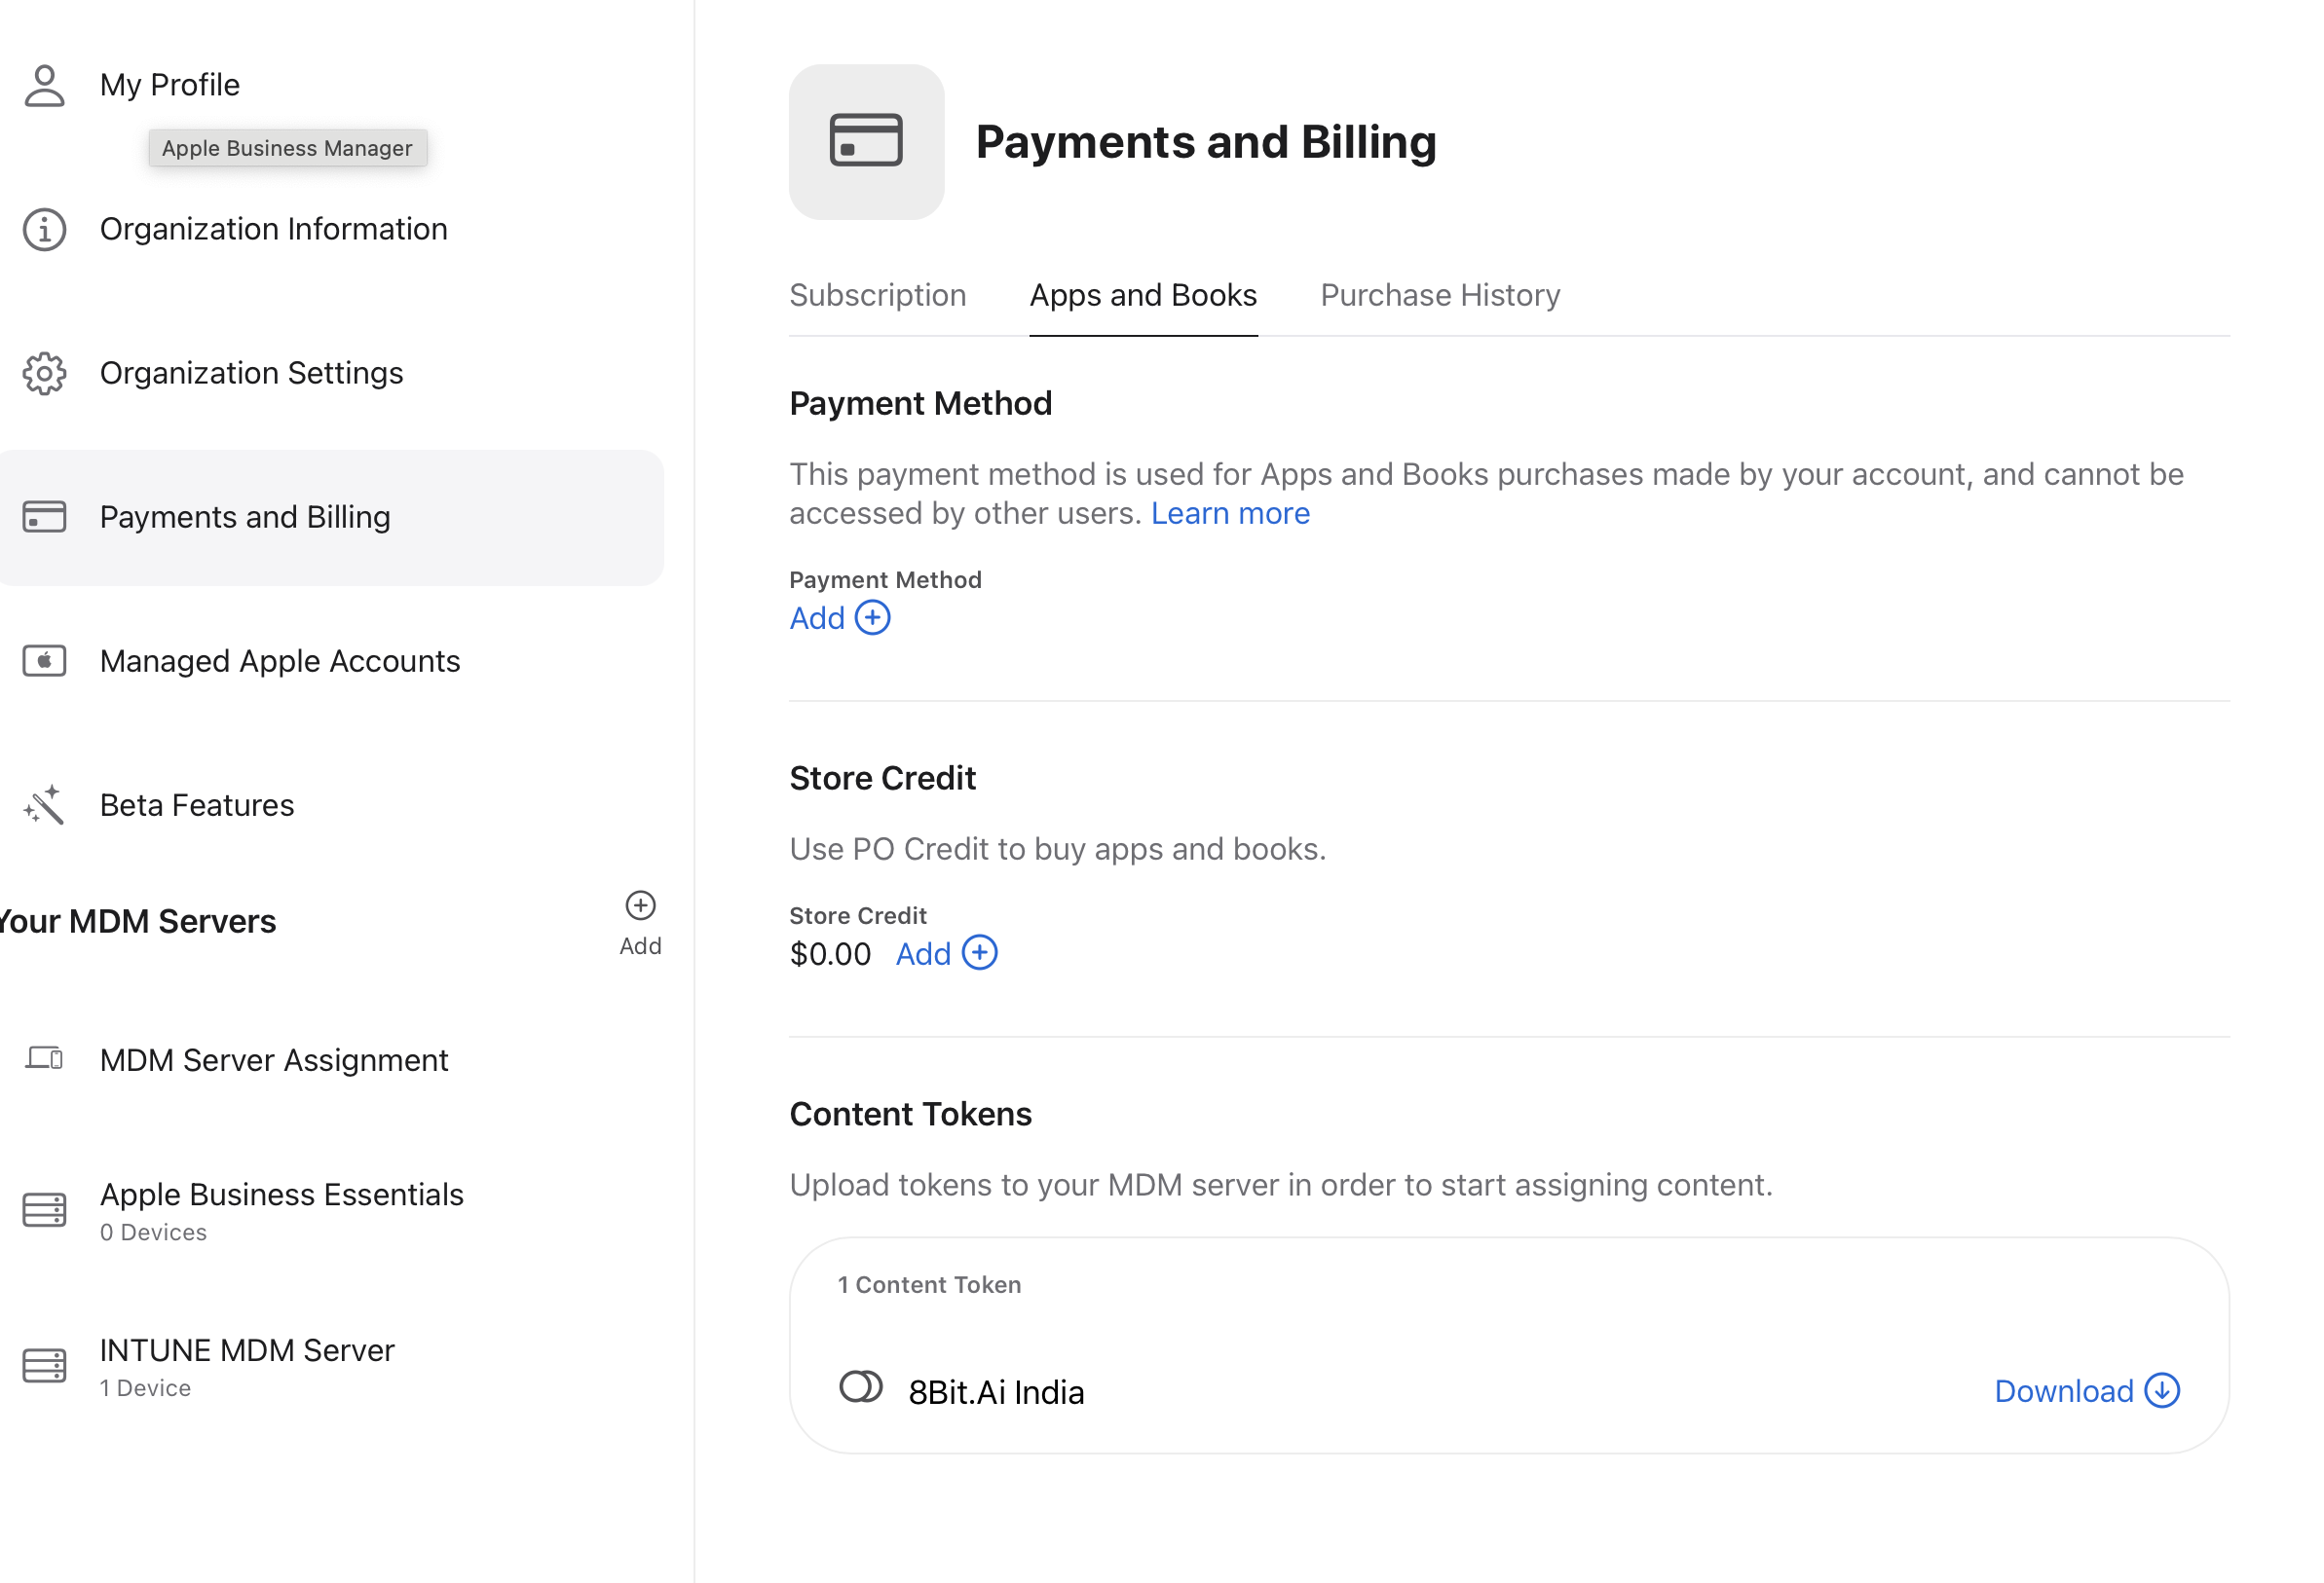

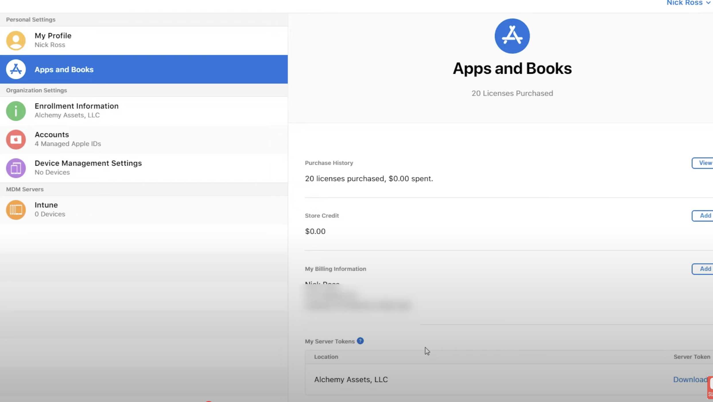

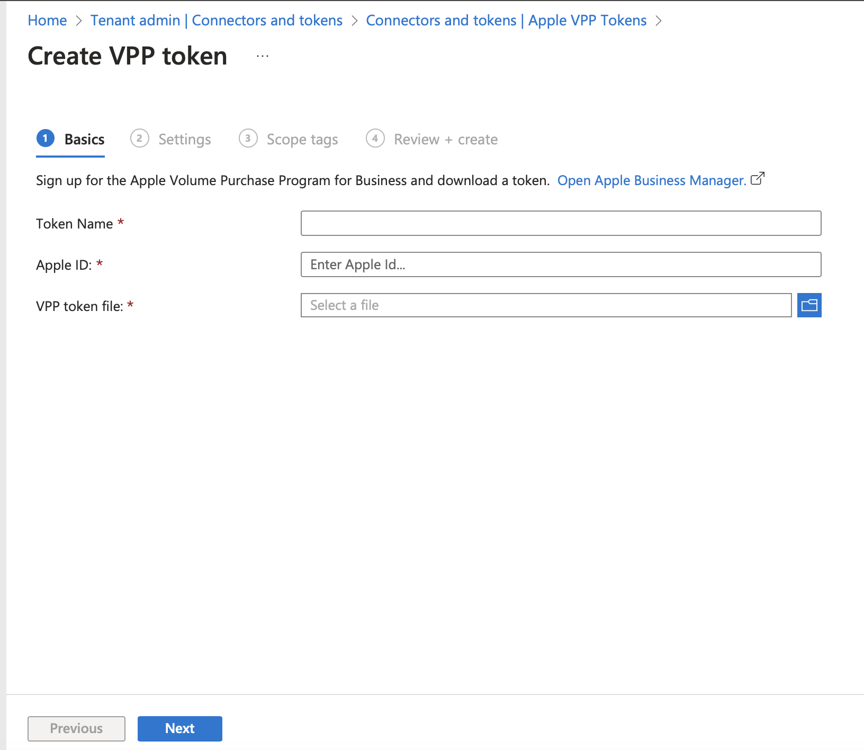
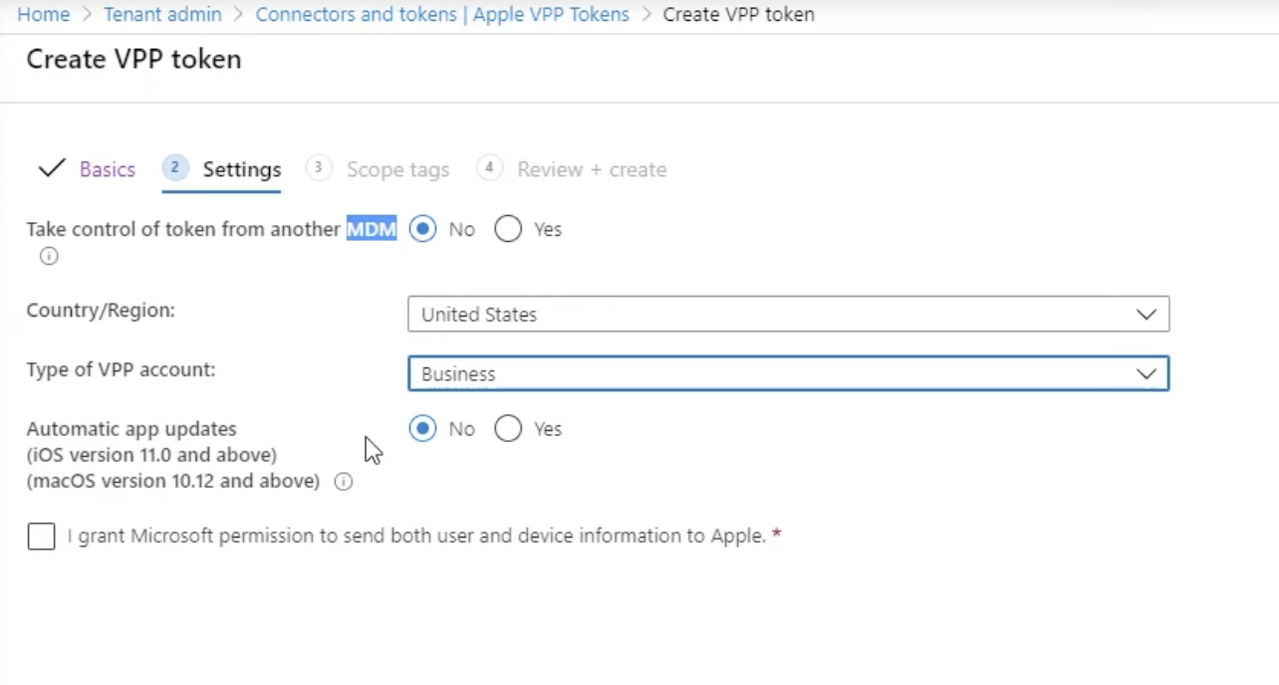
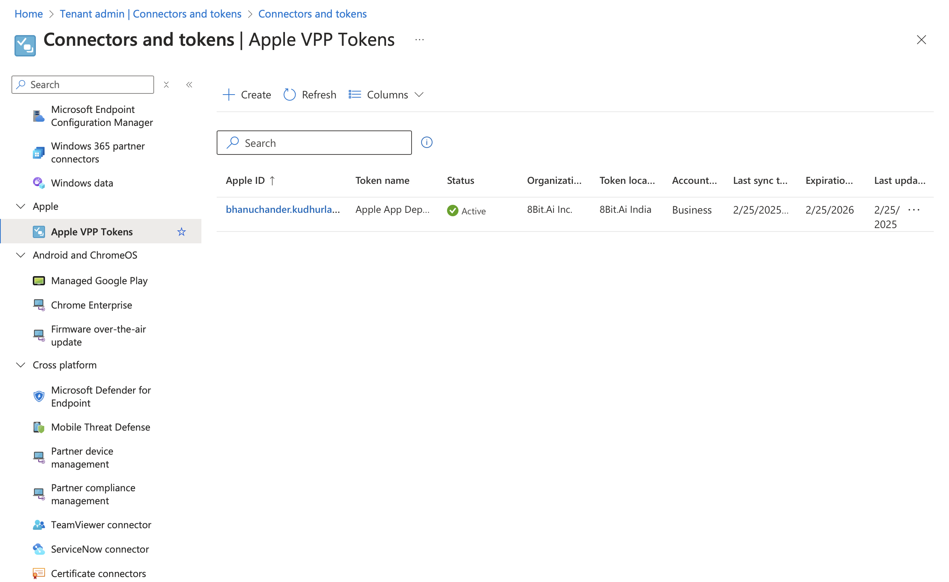
How many tokens can I upload?
You can upload up to 3,000 tokens in Intune.
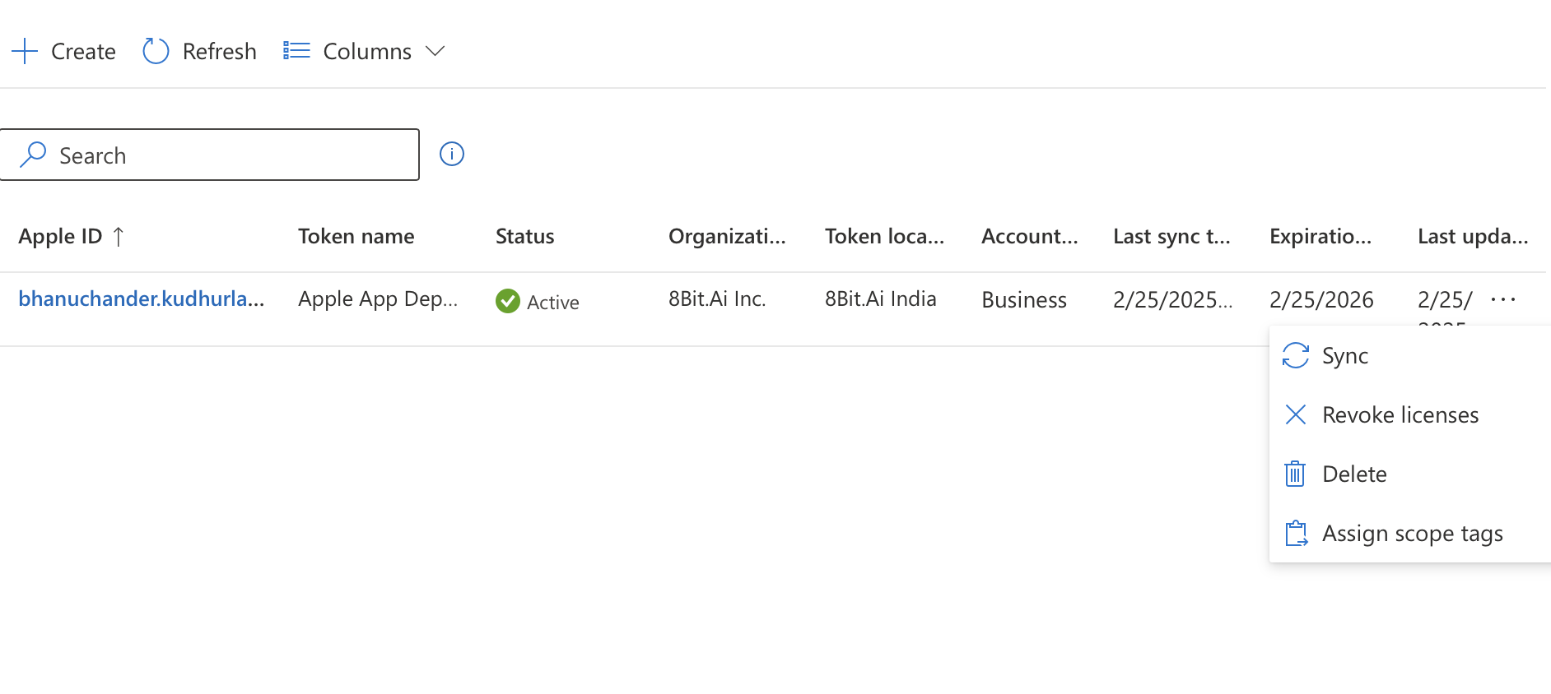
Sync the token, After synchronisation, we can find the apps which are purchased from the Appstore reflectct under Intune → Apps → macOS 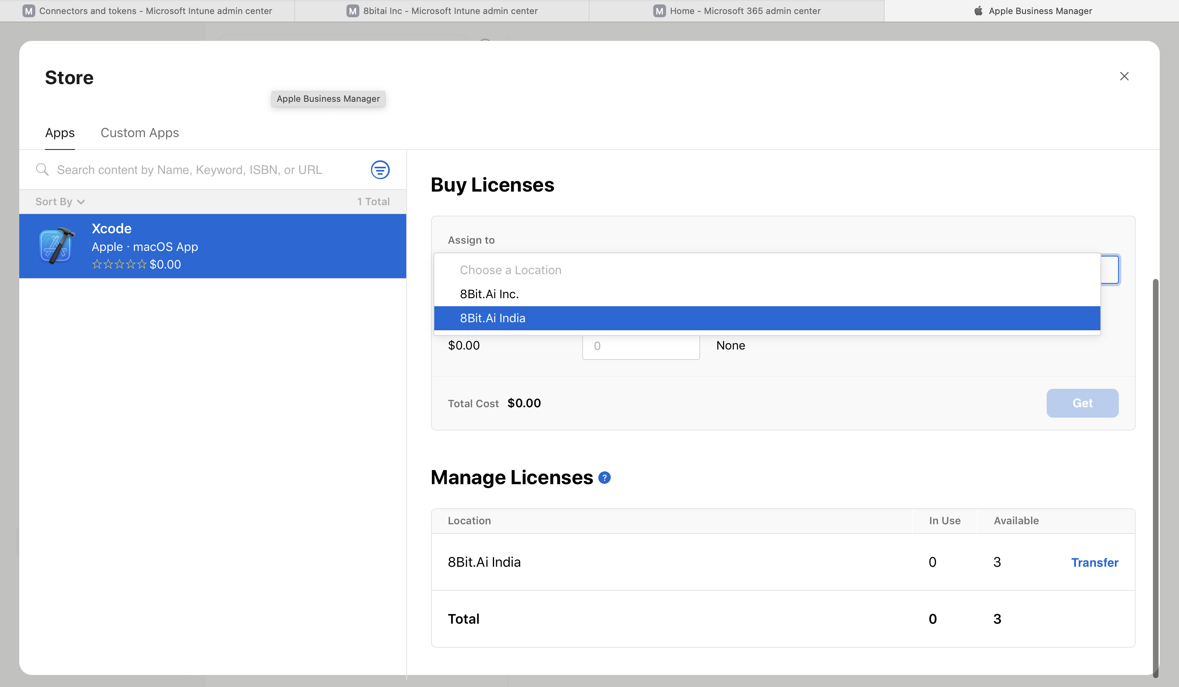

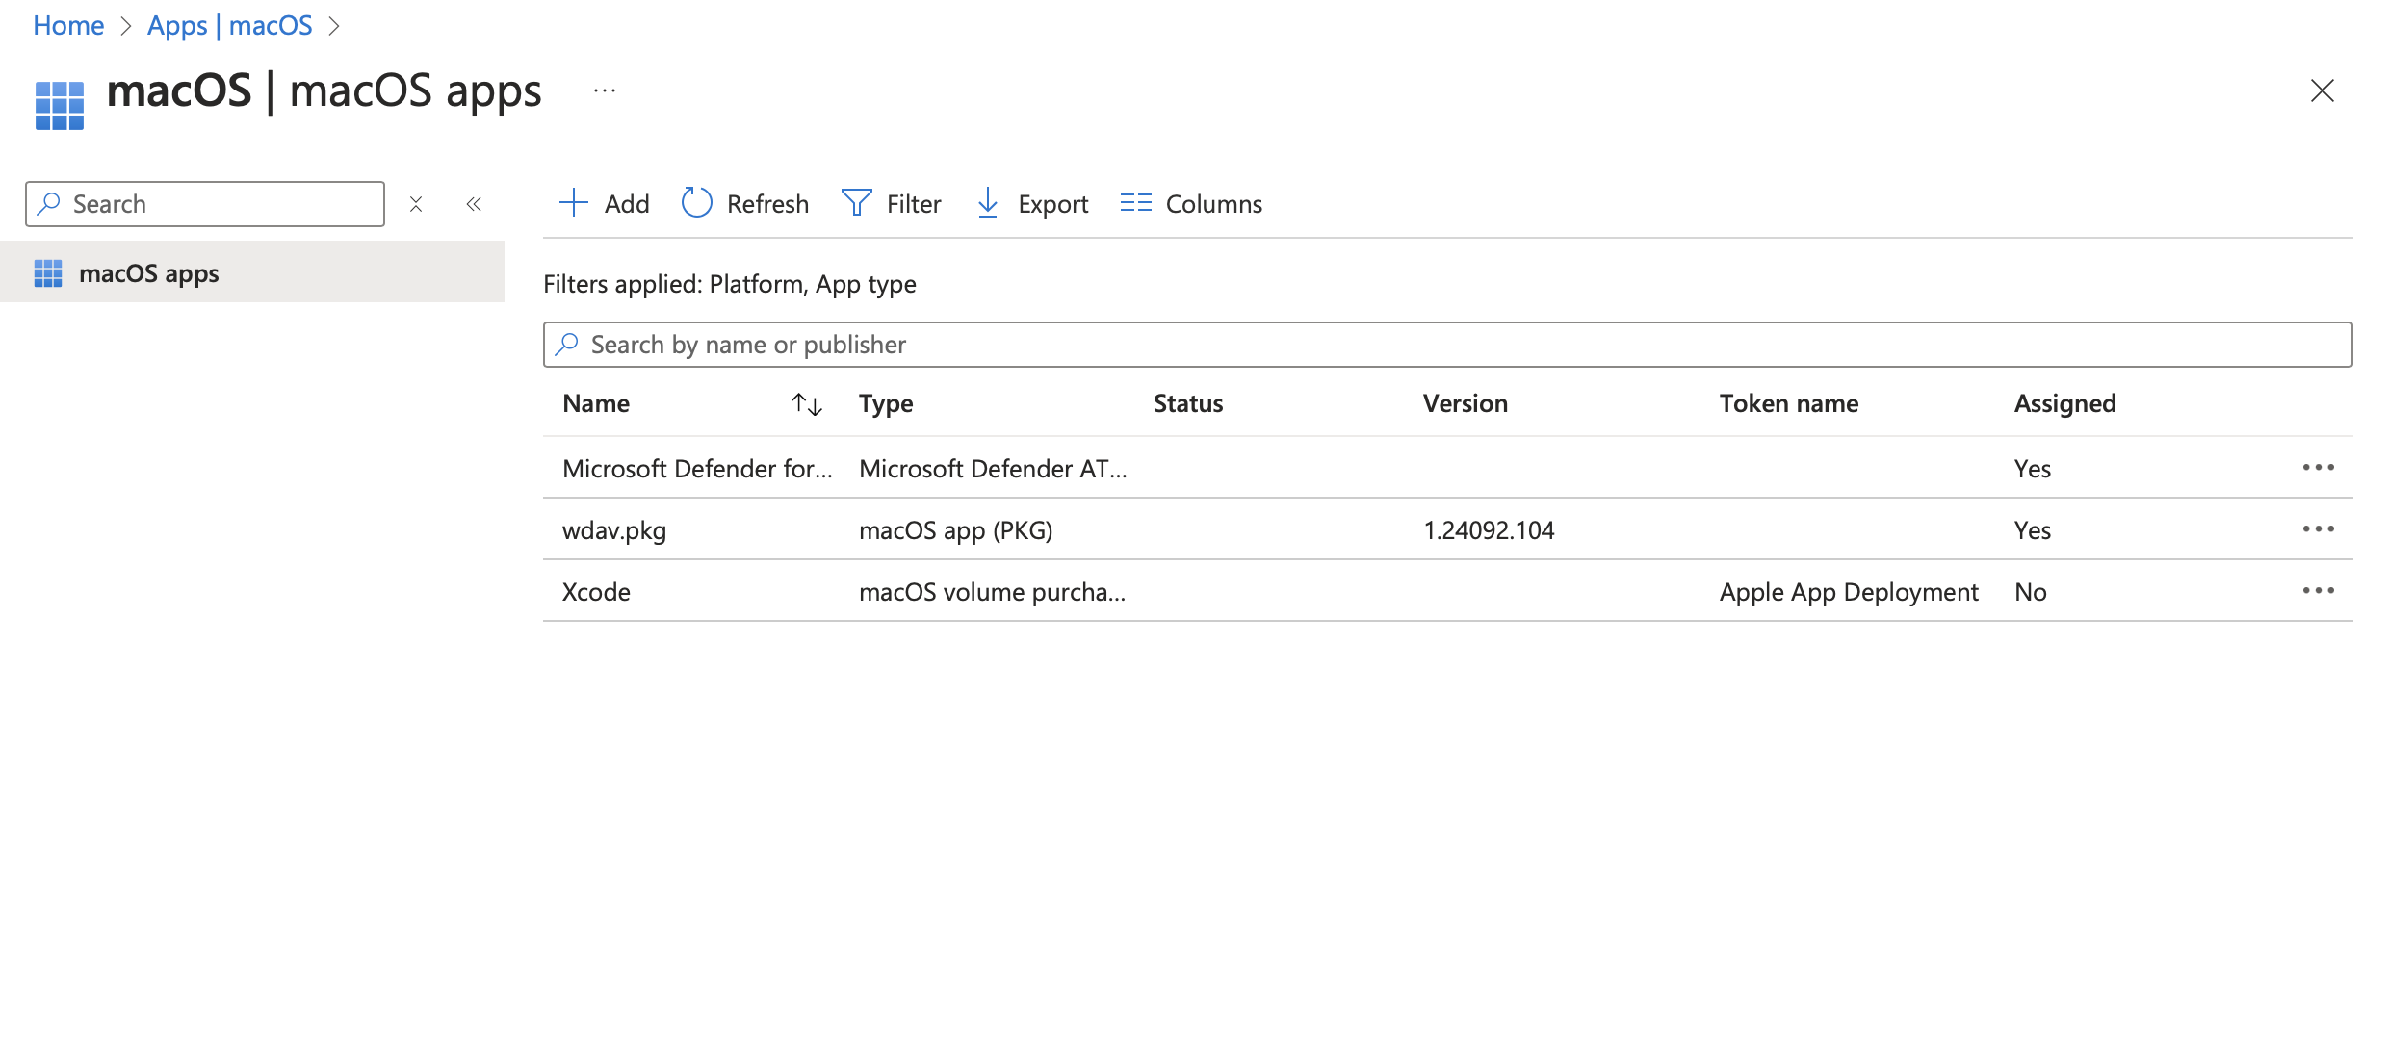
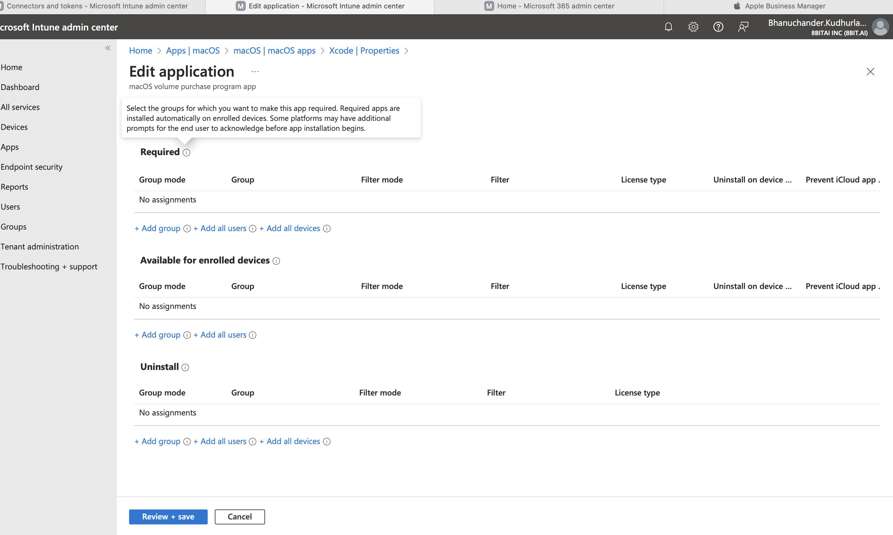

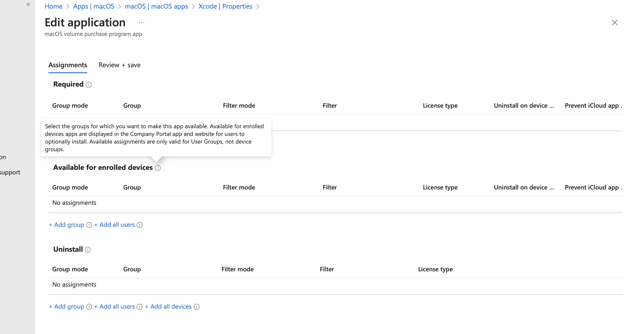

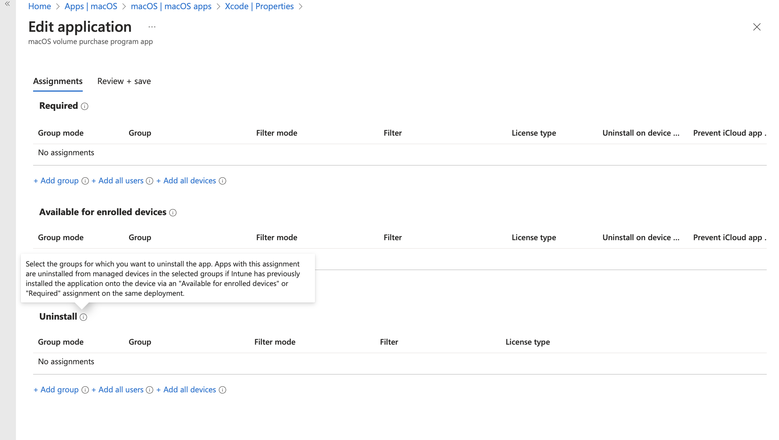
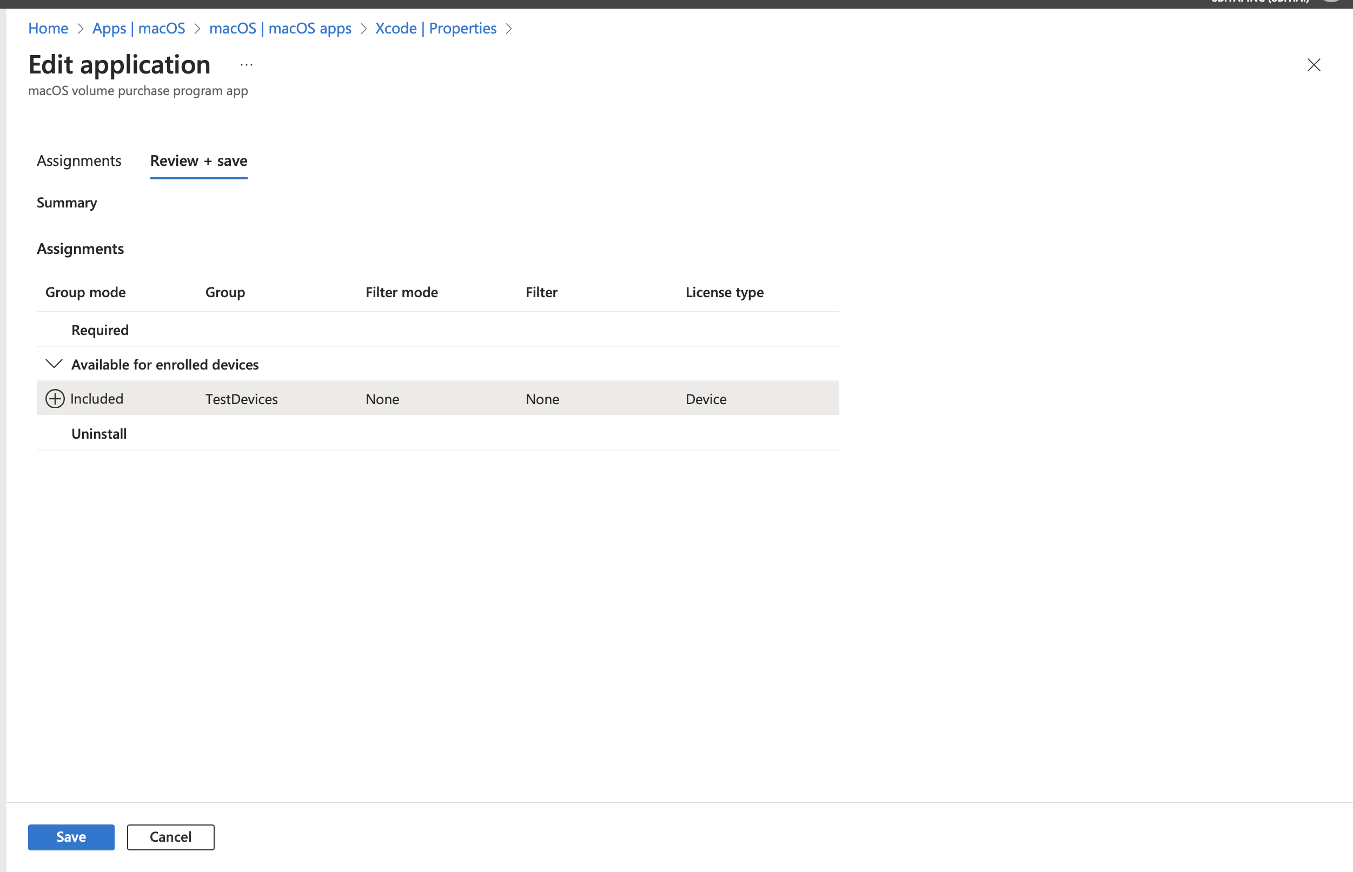

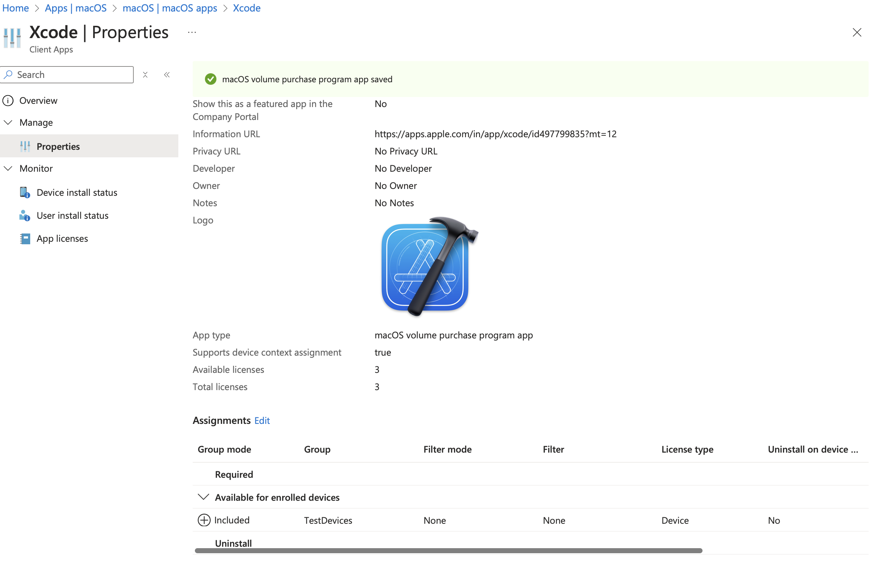

Step 2: Deploy Apps
- Go to Intune → Apps → macOS → Add
- Choose Store App (VPP) or upload a PKG Installer
- Assign to user or device groups.

6. Enforce Compliance & Security Policies
To ensure macOS devices comply with security standards, enforce compliance policies.

Step 1: Create Compliance Policies
- In Intune → Devices → Compliance Policies → macOS → Create Policy
- Set rules like:
  - Require File Vault encryption
  - Enforce password policies
  - Require minimum OS version
  - Block jailbroken devices

Step 2: Enforce Conditional Access
- In Intune → Endpoint Security → Conditional Access
- Create a policy that blocks non-compliant devices from accessing Microsoft 365 (email, Teams, etc.).

7. Manage Updates & Patching
Ensure devices stay up to date.

Step 1: Configure Update Policies
- In Intune → Devices → macOS → Update Policies
- Set Automatic Updates
- Delay updates if needed for testing before deployment.

8. Monitoring & Troubleshooting

Step 1: Check Enrollment Status
- In Intune → Devices → macOS → Enrollment Status Page, review errors.

Step 2: View Logs on macOS
- Use Company Portal logs (/Library/Logs/Microsoft/Intune)
- Run system_profiler SPConfigurationProfileDataType in Terminal to check profiles.

Which Type of Profile Do You Need?
- Wi-Fi/VPN → Use the XML method above.
- System Settings (Dock, Restrictions, etc.) → Use ProfileCreator.
- Deploy via MDM → Use a signed .mobileconfig file.

Microsoft Learn Documentation:
- Device Compliance Policies: This guide provides step-by-step instructions on creating rules and settings that devices must meet to be considered compliant.
learn.microsoft.com
- Endpoint Security Policies: Learn how to configure device security and manage security tasks using the Endpoint Security node in Intune.
learn.microsoft.com
- Configuration Profiles: Understand how to configure policies in preparation for device deployment.
learn.microsoft.com
How do I add local admin account to mac os using intune or ABM
To add a local admin account to macOS devices using Intune or Apple Business Manager (ABM), you can do so using a configuration profile in Intune, leveraging the macOS Device Configuration profiles to create a local admin account. Here are the steps for each approach:

Method 1: Add Local Admin Account via Intune using Custom Profile
- Create a Custom Configuration Profile in Intune:
  - You can use Apple’s Device Management (MDM) framework to configure macOS to create a local admin account.

Steps to create a custom profile:
  - Log in to the Microsoft Intune portal:
    - Go to Microsoft Intune Admin Center.
  - Navigate to Device Configuration:
    - In the left pane, go to Devices > macOS > Configuration profiles.
  - Create a new profile:
    - Click on Create Profile.
    - For the Platform, select macOS.
    - Choose Custom for the profile type.
  - Define the Custom Profile settings:
    - Provide a name for your profile, like "Add Local Admin Account".
    - Under Configuration settings, click Add to add a new OMA-URI setting.
  - Configure the OMA-URI for creating a local admin account:
    - OMA-URI Settings are used to push commands and settings to the macOS device.
    - Use the following Apple MDM payload for creating a local admin account:
Key for Local Admin Account:
      - Key Name (Oma-Uri): com.apple.MDM.addAdminAccount
      - Data type: String
      - Value: Create a string with the following structure:
{
"username": "localadmin",
"password": "P@ssw0rd123",
"is_admin": true
}
This will create a user account called localadmin with the password P@ssw0rd123 and give it admin privileges.
  - Assign the profile:
    - Assign the profile to a group of devices or users as necessary.
  - Save and deploy:
    - Click Save, and the local admin account will be created on the selected devices after the profile is applied.
Important Considerations:
  - If you plan to push this setting to a large number of devices, make sure the password is secure and follows your security policies.
  - Using custom OMA-URI settings requires familiarity with Apple’s MDM commands and payloads, so you may need to consult Apple's MDM documentation if you need more complex configurations.

Method 2: Use ABM for Automated Device Enrollment and Admin Setup
While Apple Business Manager (ABM) doesn't directly provide an option for adding a local admin account, you can combine it with Intune for device setup.
- Automated Device Enrollment:
  - In ABM, devices that are enrolled via Automated Device Enrollment (ADE) will automatically be enrolled in Intune for management.
- Set Up Local Admin Accounts through Intune:
  - You will still use the Custom Profile method in Intune (as described above) to create a local admin account for macOS devices once they are enrolled.

Method 3: Using Apple Script with Intune to Add Local Admin
Another option is to use AppleScript to create the local admin account and deploy it via Intune.
- Create the AppleScript: You can create a script with the following AppleScript code to create a local admin user:
- sudo sysadminctl -addUser localadmin -fullName "Local Admin" -password "P@ssw0rd123" -admin
- Deploy via Intune:
  - Once the script is ready, you can deploy it through Intune using the Scripts section.
    - Go to Devices > macOS > Scripts in Intune.
    - Click Add > macOS > Shell Script.
    - Upload the AppleScript file, set deployment settings (such as whether it runs as root), and assign the script to the target devices.

Summary
- Intune is the recommended way to create a local admin account on macOS using either Custom profiles (via OMA-URI) or AppleScript.
- ABM doesn't provide a direct way to create a local admin account, but it facilitates Automated Device Enrollment and deployment of the management profile from Intune to macOS devices.
By using Intune, you can configure and maintain local admin accounts securely across your devices, helping with administrative tasks while adhering to security policies.
Let me know if you need more details or help with specific steps!

Device platform Restrictions

